**Project:**

Motorola Phone Book

**Description:**

This project is intended to demonstrate how a company can create a phone book for its customers, be able to search, edit and delete the contacts.

The project is done using Python as the programming language and Json file.

**Installation:**

You will require Python installed in the computer and have a text editor.

For the json file, please change the location of the file to point to your own computer environment.

**How to Use This Project:**

Once you have the environment set, you just run the program. It will display the menus on the screen.

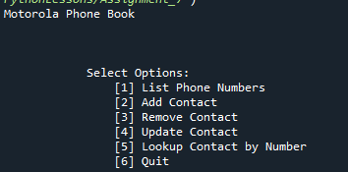

Press 1 to list all the contacts in the phonebook.

Press 2 to add new contacts

Press 3 to delete an existing contact from the phone book

Press 4 to edit an existing contact

Press 5 to search a contact

Press 6 to quit

**Adding New Contact**

You will press 2 from the main menu to get prompts to capture the necessary details. To move to next prompt you will press the Enter button. Immediately you enter the phone number the record will be saved and you will get on screen display of the saved record.

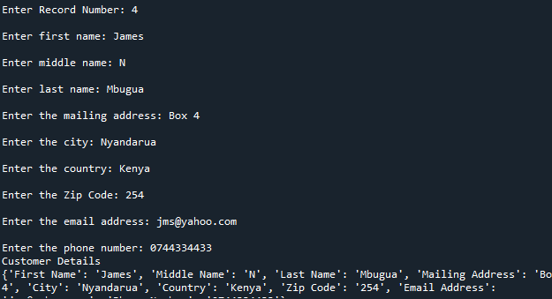

**View Phonebook Contacts**

To view the existing contacts you will select 1 from the main menu and you will see on screen the existing contacts.

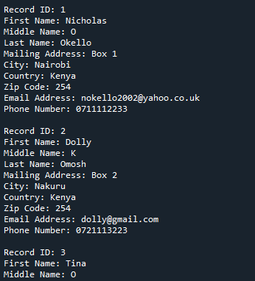

**Deleting a Contact**

If a contact is no longer needed in the phonebook, it can be deleted by pressing on 3 from the main menu. This will prompt for the record number to be deleted. The system will search the record and if found delete it.

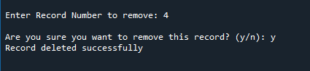

**Updating Contacts**

To edit a contact, you will press 4 on the main menu. The system will prompt for a record number to edit. It will search for that record and if found then it will prompt for the field to edit. Select the required option and then enter the new value. The system will save automatically on pressing the enter button.

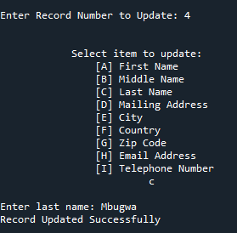

**Looking Up Contacts**

You will search through the long list of contacts by pressing 5 on main menu. This will give you a prompt for the record number to display. If the search is found then it will display the rest of details of that record.

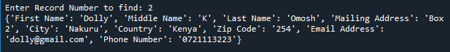

**Author:**

Nicholas Okello